**ROLL NO.: 2024510001 BATCH: A**

**NAME: Atharva Vasant Angre**

**EXPERIMENT NO: 03**

**EXPERIMENT TITLE:** Draw use case diagram. Prepare Use case specification document for given Scenario.

Objective:

1. To design Use Case Diagram.

2. To identify and implement System, Use cases, Actors, Relationships from a given case study.

3. To implement Use case specification

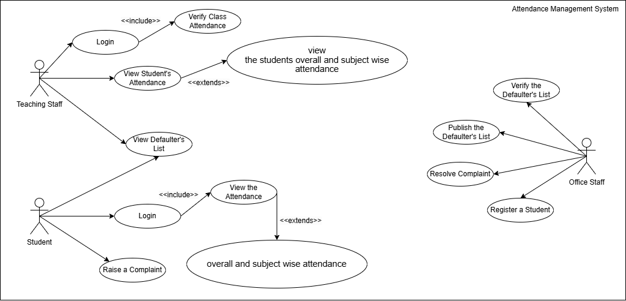

**Use Case Diagram Specification**

|  |  |
| --- | --- |
| Use Case ID: | AMS1 |
| Use Case Name: | Attendance Management System |
| Created By: | Atharva Vasant Angre |
| Date Created: | 03.12.2024 |

|  |  |
| --- | --- |
| Actor: | Student, Teaching Staff, Office Staff |
| Description of use cases: | * Login: Allows both Teaching Staff and Students to log into the system securely. * View Student's Attendance: Enables Teaching Staff to view individual or class-wise attendance records. * Verify Class Attendance: Teaching Staff verifies and updates attendance records. * View Defaulter'sList: Teaching Staff can view students who fall below the attendance threshold. * View the Attendance: Students can view their overall and subject-wise attendance. * Raise a Complaint: Students can report any discrepancies in their attendance. * Resolve Complaint: Office Staff handles and resolves complaints raised by students. * Register a student: Office Staff registers new students in the system. * Publish the Defaulter's List: Office Staff officially releases the list of defaulters. * Verify the Defaulter's List: Office Staff validates the accuracy of the defaulter's list. |
| Preconditions: | * Teaching Staff and Students must have valid credentials to log into the system. * The system must contain preloaded attendance records for students. * Office Staff must have administrative access to manage student records. |
| Postconditions: | * Login: Users are redirected to their respective dashboards. * Verify Class Attendance: Attendance records are updated in the system. * View Attendance: Students can view accurate, updated attendance information. * Raise a Complaint: Complaints are logged and forwarded to the Office Staff for resolution. * Resolve Complaint: Complaints are resolved, and the changes are reflected in the system. * Publish Defaulter's List: The list is made accessible to all concerned parties. |
| Extends: | * View Student's Attendance: Teaching Staff can use this to extend View the Attendance, adding a higher level of detail. * Overall and Subject-wise Attendance: Extends both View Student's Attendance and View the Attendance for a detailed breakdown. |
| Includes: | * Verify Class Attendance: Includes Login for Teaching Staff. * View Attendance: Includes Login for Students. * Publish Defaulter's List: Includes Verify Defaulter's List to ensure accuracy. |
| Assumptions: | * Attendance records are updated daily in the system. * Defaulter thresholds (e.g., minimum attendance percentage) are preconfigured and known to all users. * Complaints are resolved within a reasonable timeframe. |